Broj Feb. 3, 2014 Datum:

G-din. Thomas Trowbridge

Academic Adviser

Američki univerzitet u Bosni i Hercegovini

Mije Keroševića Guje 3

75000 Tuzla, Bosna i Hercegovina

*Notification on Academic Progress*

Dear **Amar Iković**

This letter is to fully inform you of your Academic Progress and Academic standing. In keeping to a System of Academic Progress SAP, the American University of Bosnia and Herzegovina has specific standards for qualitative and quantitative assessment of student progress for successful matriculation. All students must maintain a GPA of 2.0 for graduation and successful matriculation to the next semester or Academic year. Your last Semester results are as follows:

Cumulative Grade Point Average = Quality Points Accumulated **/** Credits Attempted **1,59**

These standards are included below. Based on the current records available on this date, the quantitative academic progress for your current semester is 16 Credits

*Undergraduate 4-year Matriculation Quantitative Standards of Progress*

1st Semester pass successfully 9 US Credit Hours/18 ECTS which are the equivalent of 3 courses

2nd. Semester pass successfully 24 US Credit Hours/48 ECTS which are the equivalent of 8 courses

3rd. Semester pass successfully 33 US Credit Hours/66 ECTS which are the equivalent of 11 courses

4th. Semester pass successfully 54 US Credit Hours/108 ECTS which are the equivalent of 18 courses

5th. Semester pass successfully 63 US Credit Hours/126 ECTS which are the equivalent of 21 courses

6th. Semester pass successfully 84 US Credit Hours/168 ECTS which are the equivalent of 28 courses

7th. Semester pass successfully 93 US Credit Hours/186 ECTS which are the equivalent of 31 courses

8th. Semester pass successfully 114 US Credit Hours/228 ECTS which are the equivalent of 38 courses

Based on the current records available on this date, the qualitative academic progress for your previous semester is a Grade Point Average GPA of 1,59 ___ Cumulative for__1___ Semester _1,59____

*Undergraduate 4-year Matriculation Qualitative Standards of Progress*

1st . Semester maintain a Grade Point Average GPA of 1.25 with 9 US Credit Hours/18 ECTS which are the equivalent of 3 courses

2nd. Semester maintain a Grade Point Average GPA of 1.50 with 24 US Credit Hours/48 ECTS which are the equivalent of 8 courses

3rd. Semester maintain a Grade Point Average GPA of 1.75 with 33 US Credit Hours/66 ECTS which are the equivalent of 11 courses

4th. Semester maintain a Grade Point Average GPA of 2.0 with 54 US Credit Hours/108 ECTS which are the equivalent of 18 courses

5th. Semester maintain a Grade Point Average GPA of 2.0 with 63 US Credit Hours/126 ECTS which are the equivalent of 21 courses

6th. Semester maintain a Grade Point Average GPA of 2.0 with 84 US Credit Hours/168 ECTS which are the equivalent of 28 courses

7th. Semester maintain a Grade Point Average GPA of 2.0 with 93 US Credit Hours/186 ECTS which are the equivalent of 31 courses

8th. Semester maintain a Grade Point Average GPA of 2.0 with 114 US Credit Hours/228 ECTS which are the equivalent of 38 courses

It is our responsibility to inform you that you have passed compliance on both standards of Academic Excellence. The AUBiH requirements for passing a course are found in your student handbook. You are to be congratulated for you achievement and AUBiH recommends you for advancement to the next semester

You can obtain all additional information and solutions from your Academic Adviser or call 033/296-415 to schedule an appointment.

Respectfully yours,

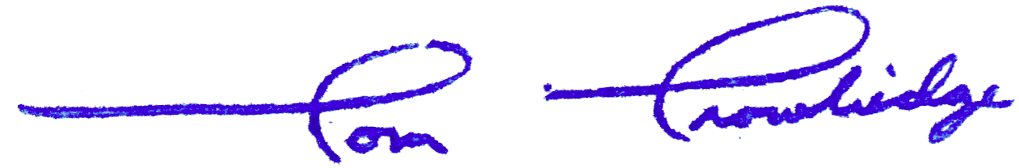

Prof. Tom Trowbridge

Academic Adviser